Power BI Hands-on Assessment

Scenario: Sales Performance Analysis with Power BI

1. Requirement 1:

Opened SQL Query Server and created a database with name PowerBiHandsOn and opened a new query where typed a new query and executed it.

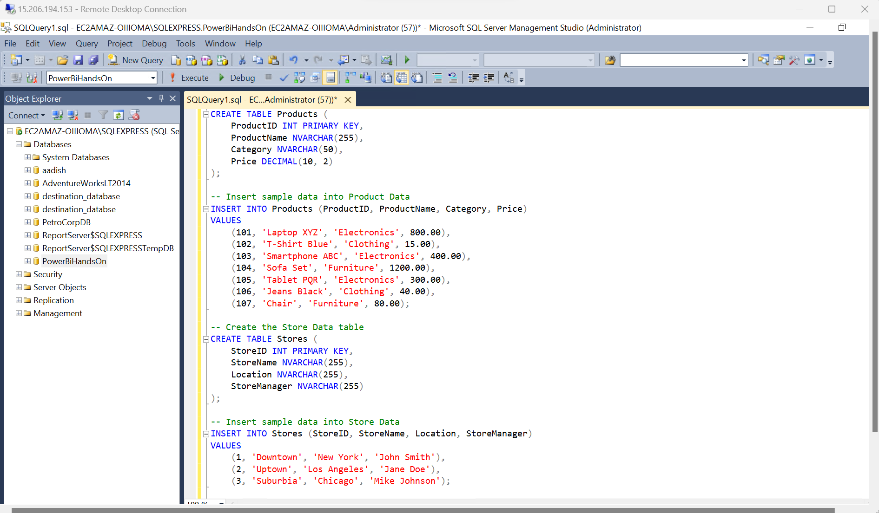

Opened Power Bi and connected it with SQL server for loading the data:

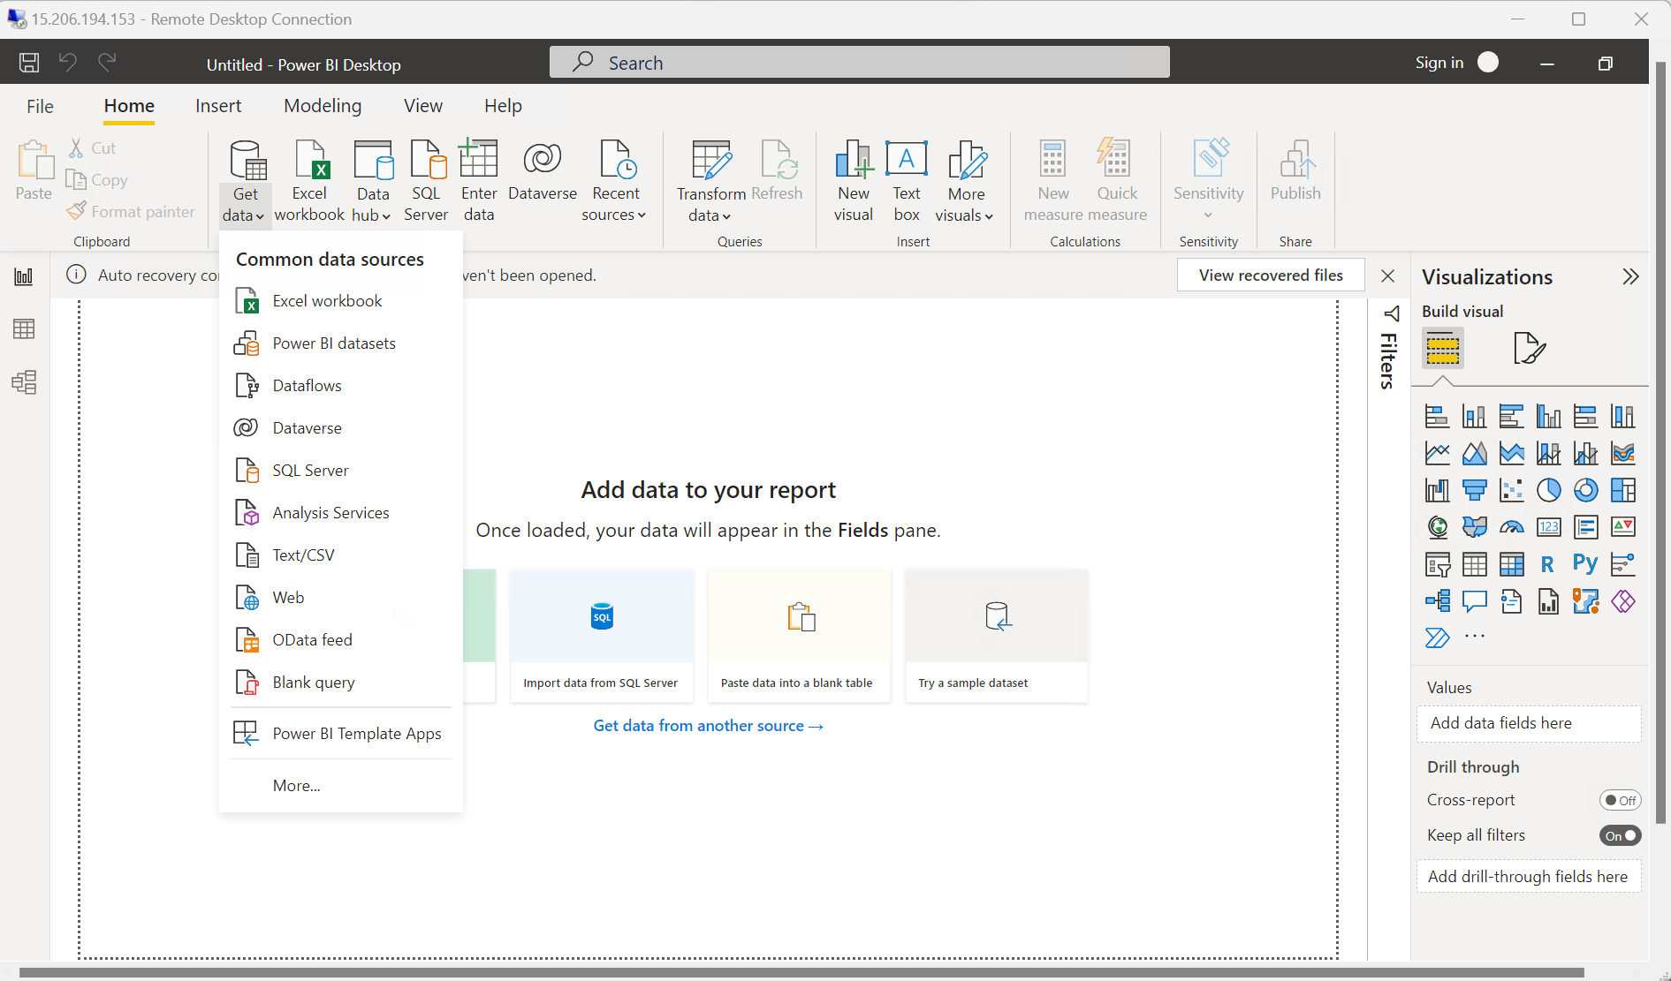

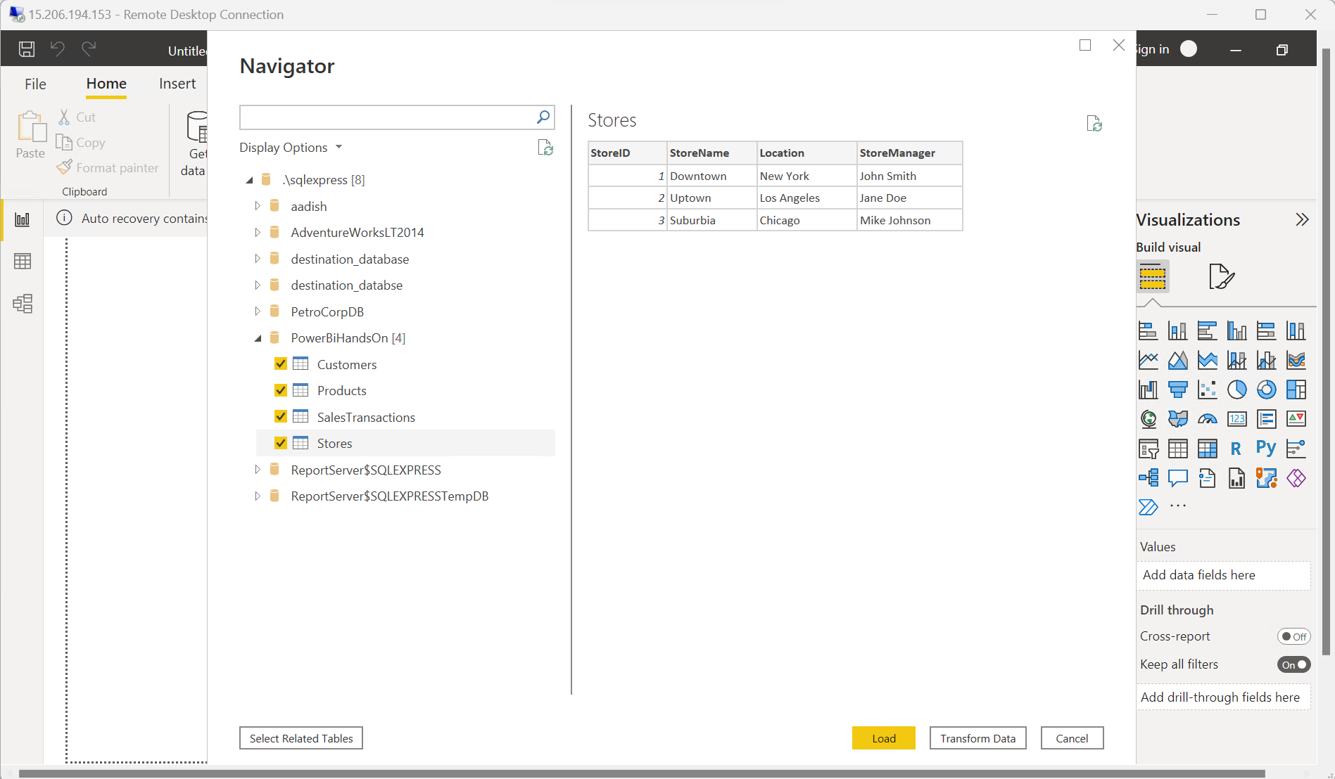

1. Requirement 2: Data Transformation
2. Merge Tables:

Clicked on transform and then chosen Merge Queries:

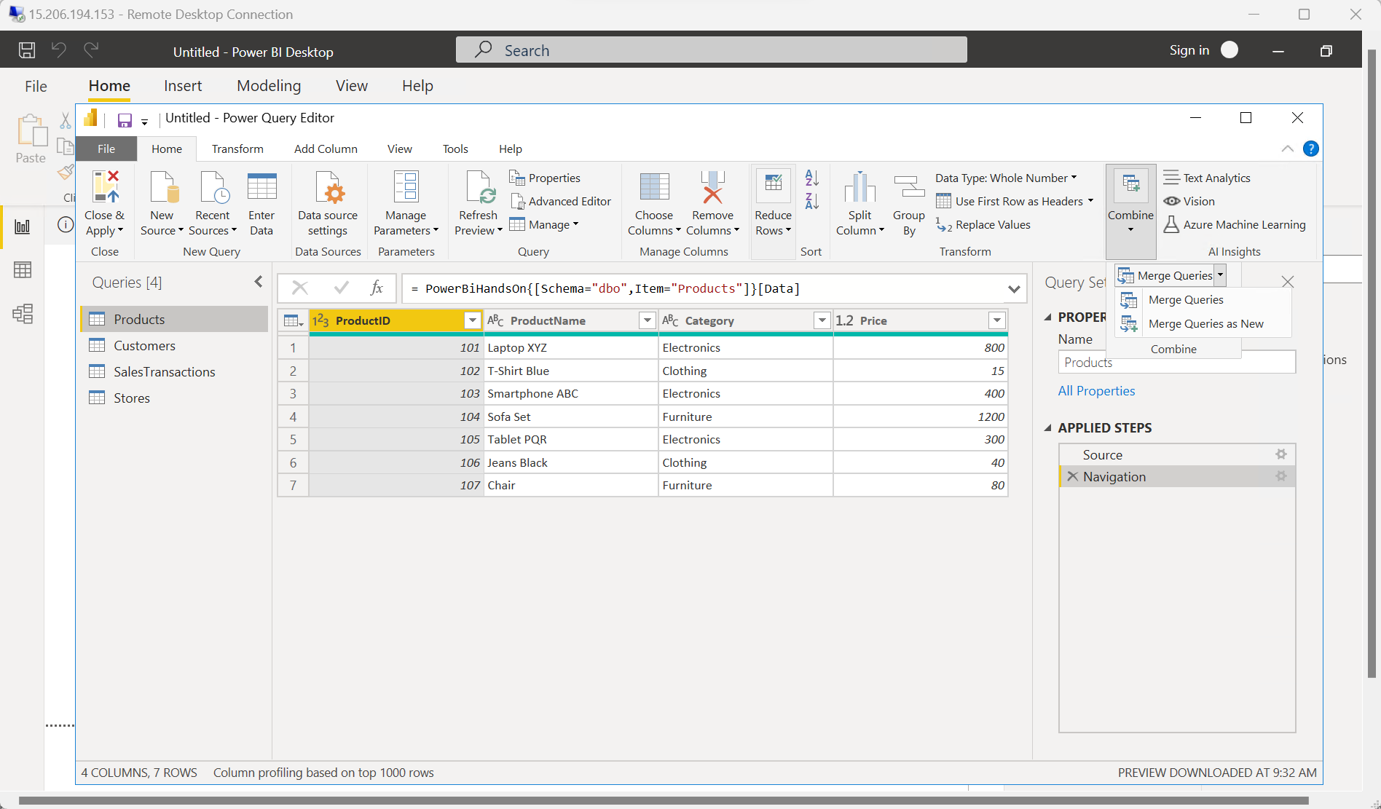

Merged Product and Sales Table:

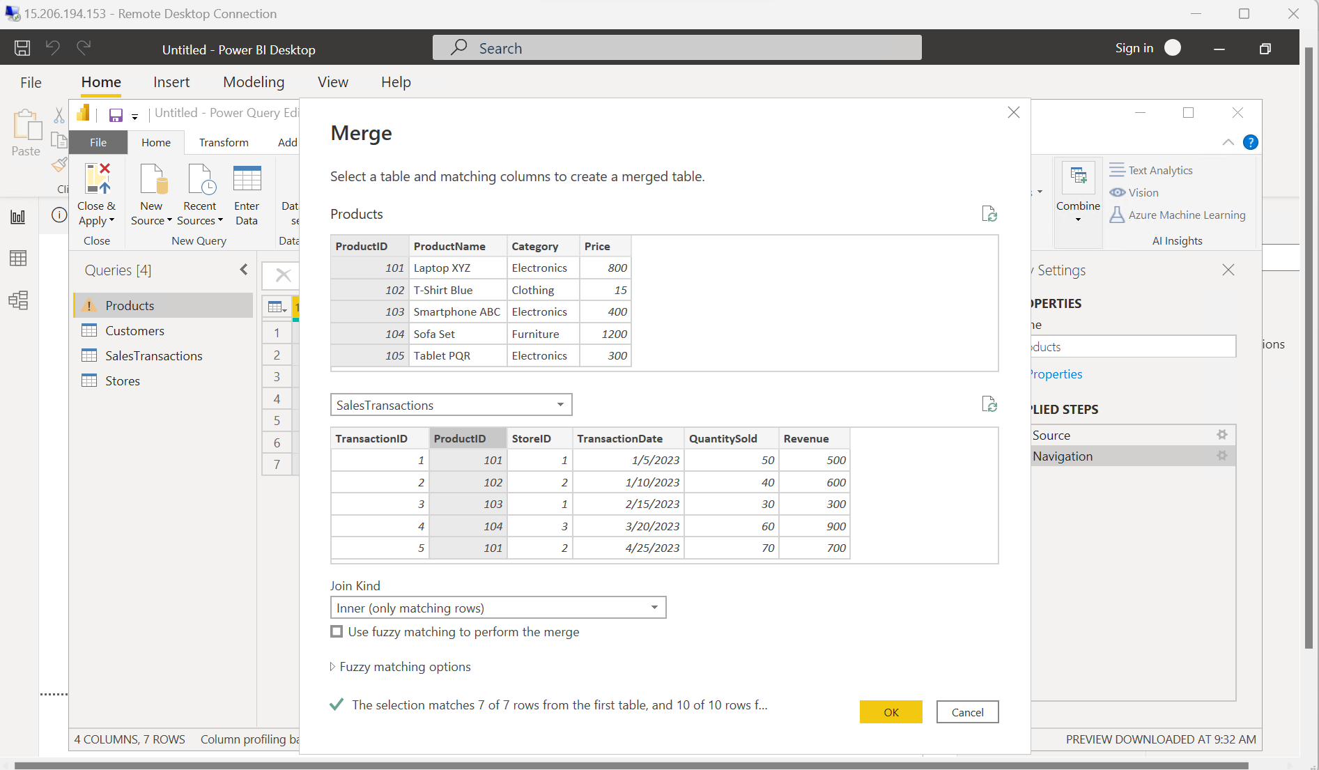

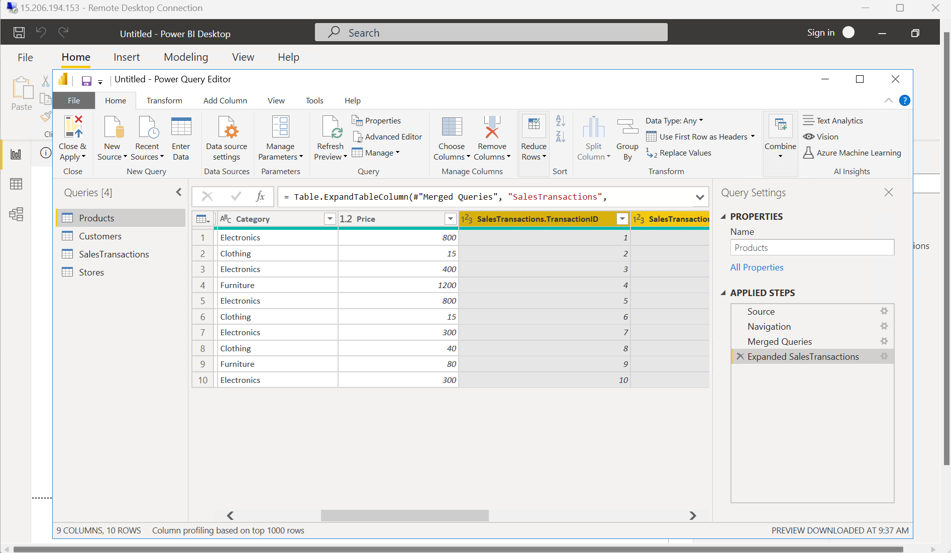

1. Clean Data:

In the customer table the phone number column looks like this:

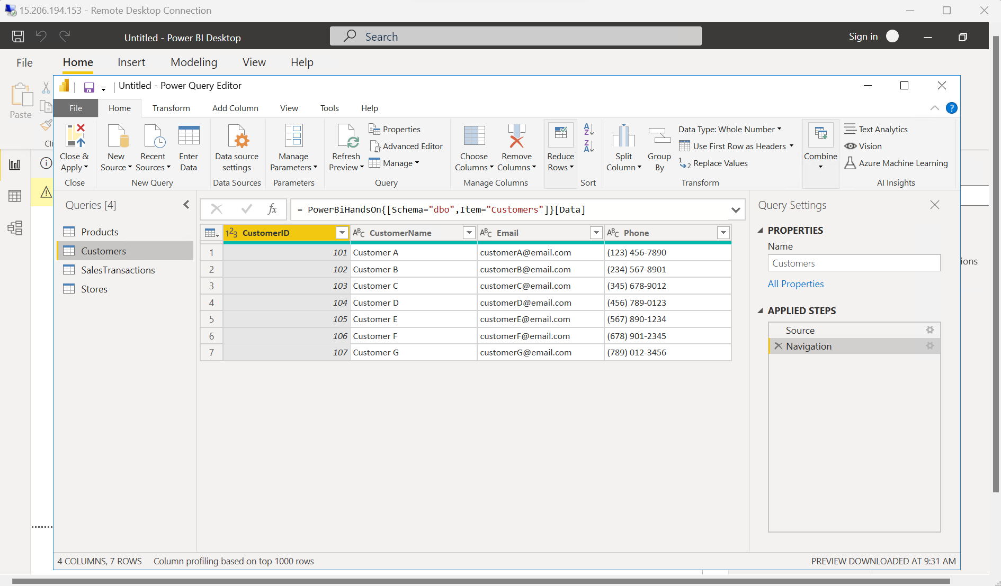

Replacing ( with blank:

In the same way replaced ),- with blank and converted the phone number to a whole number:

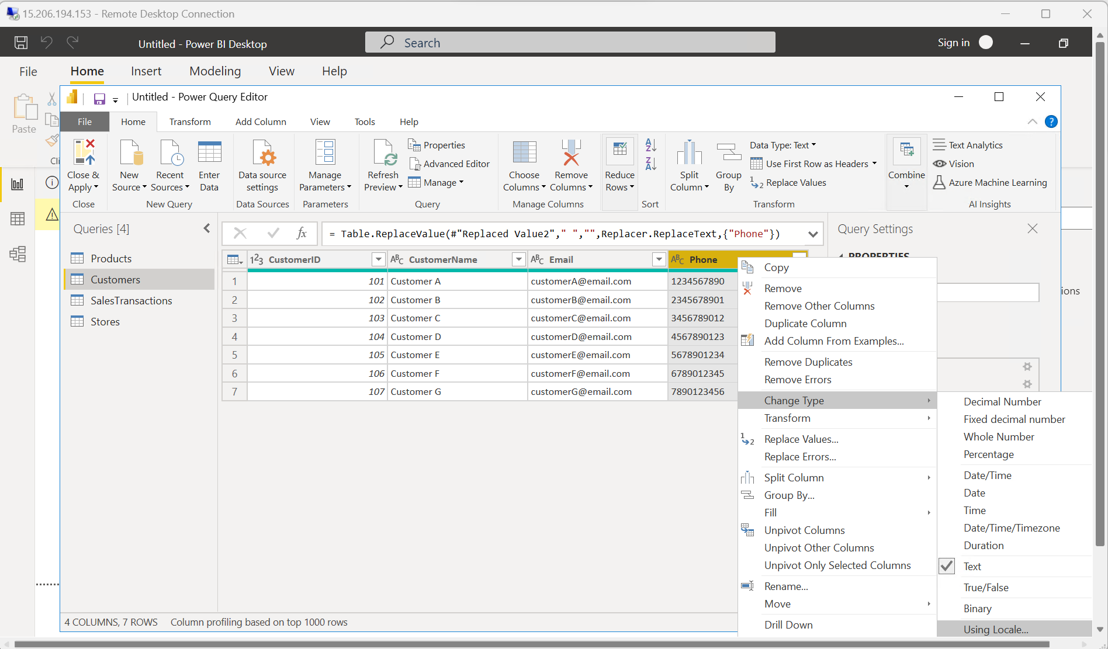

1. Create Calculated Columns:

Chosen sales table:

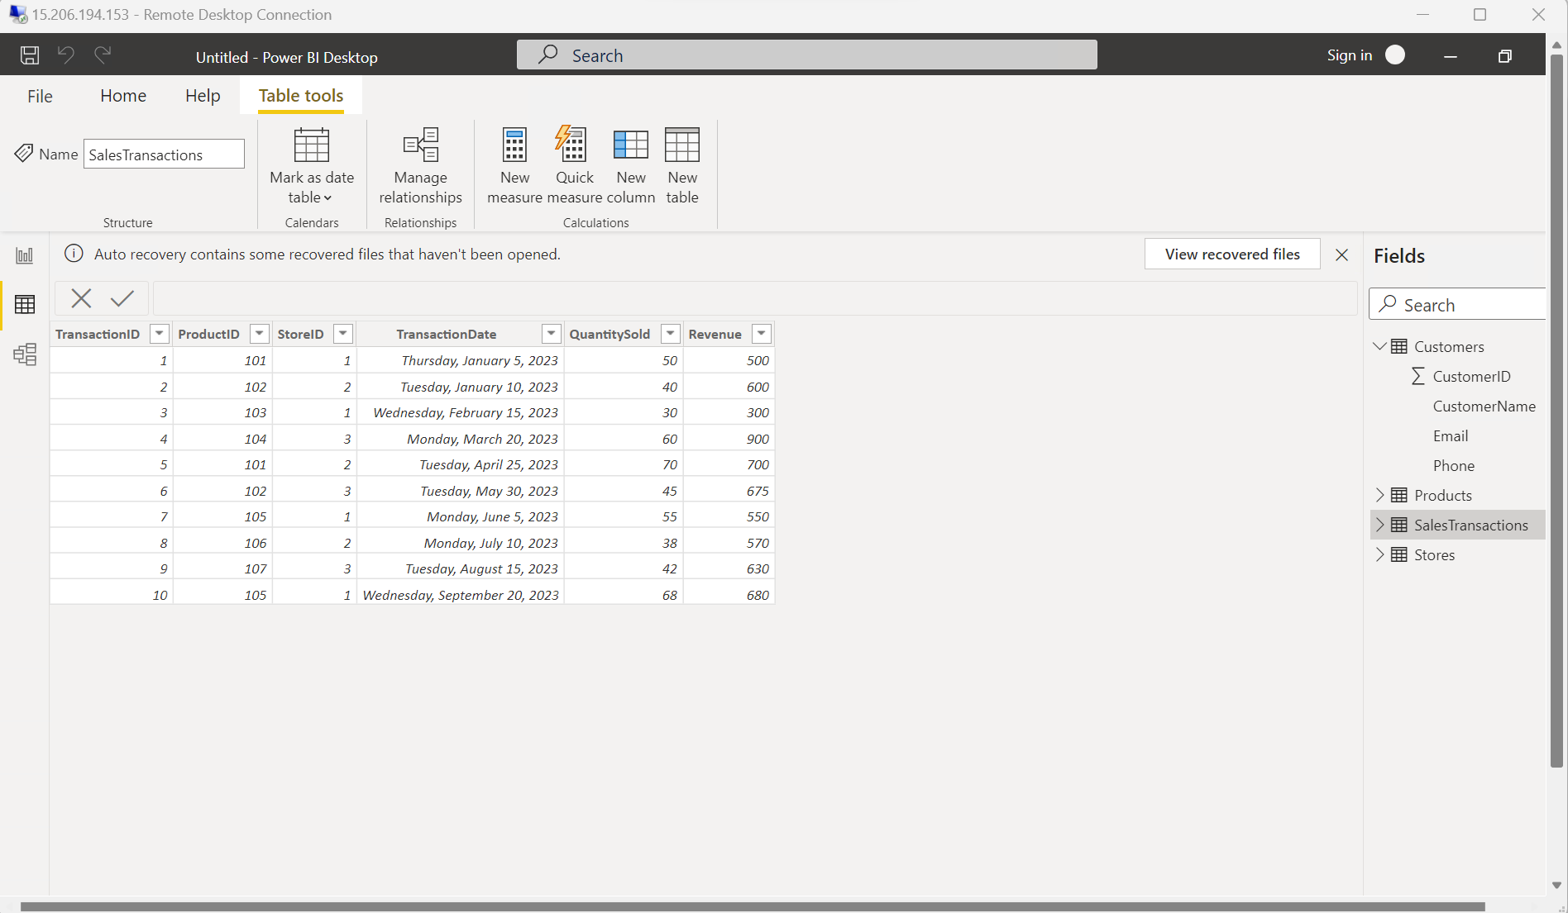

Clicked on new column and written query for it in order to calculate price per unit:

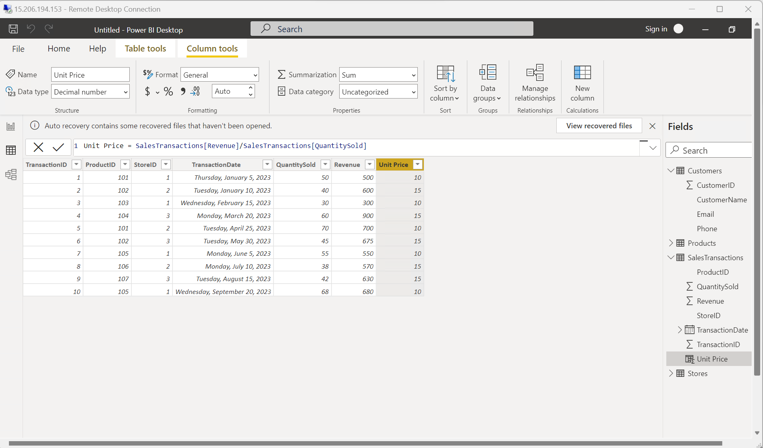

1. Filter Data:

Appling filter on column revenue in sales transaction table:

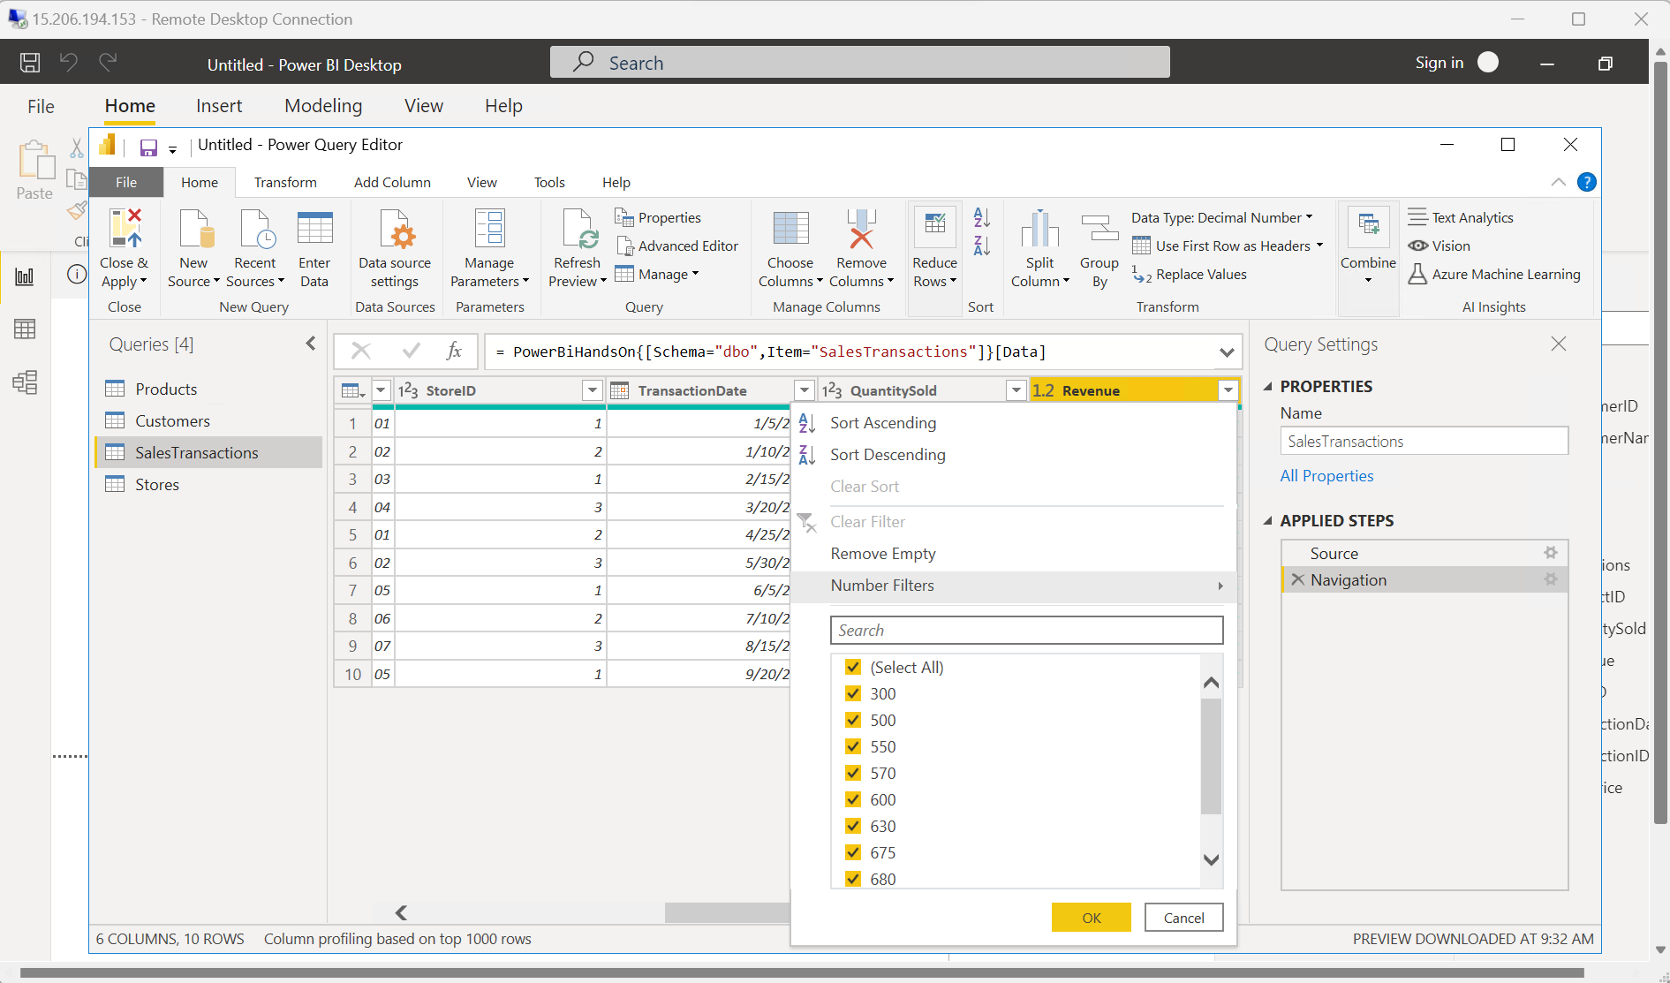

Show results where revenue is greater than 500.

1. Requirement 3: Data Modelling
2. Create Relationships:

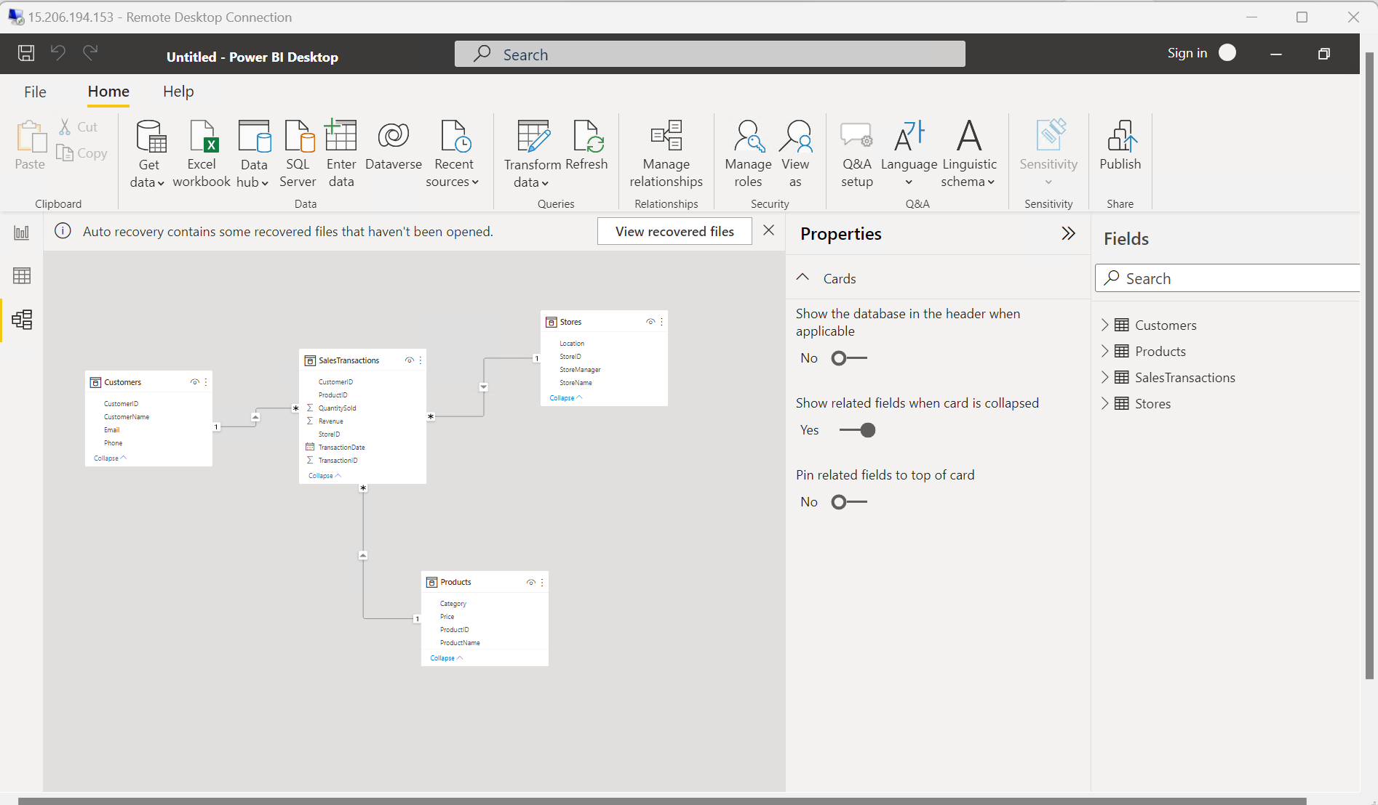

1. Create Hierarchies:

Created Hierarchies in the Transaction Date

1. Requirement 4: Business Queries and Analysis
2. Who are the top-spending customers based on their total purchase amount?

Customer ID – 1002

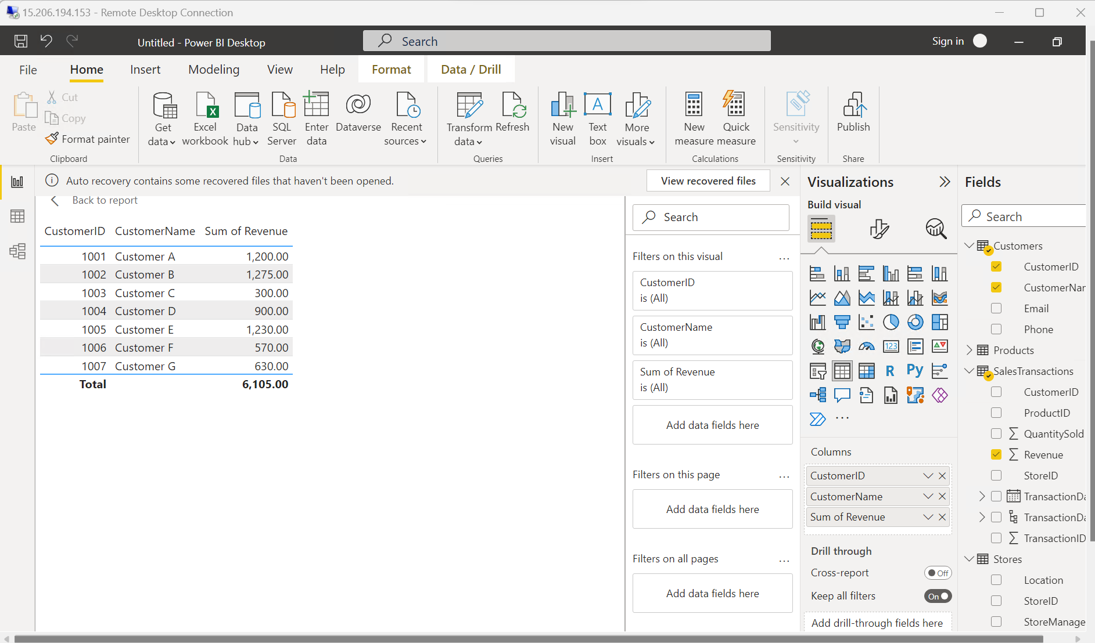

1. How is sales revenue distributed among different store managers?

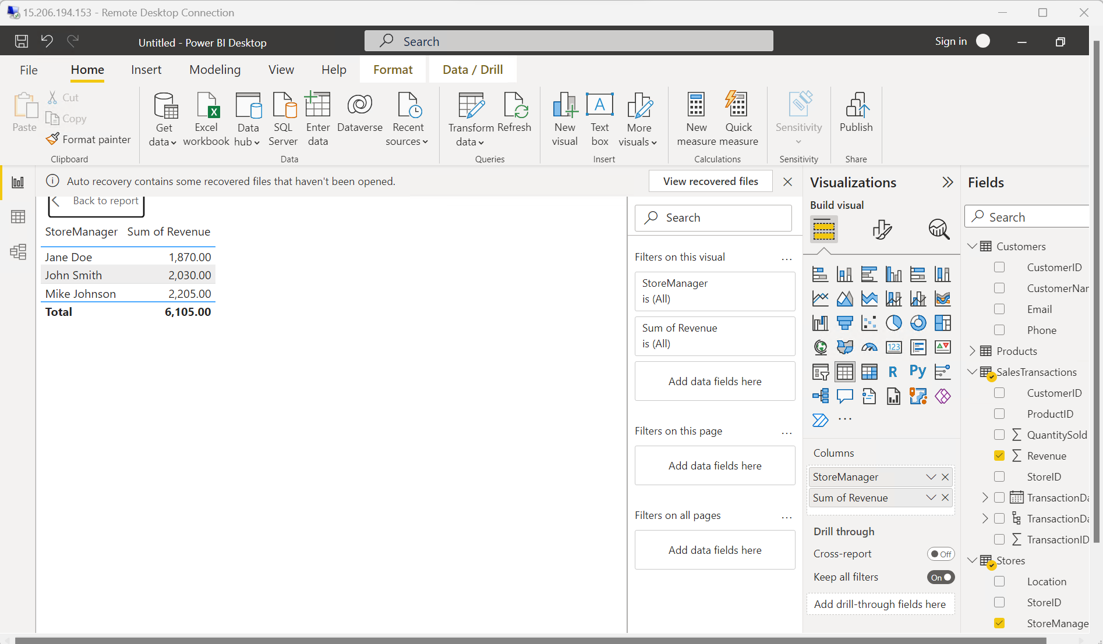

1. What is the average price of products in each category?

After selecting the prize column then selected average of price

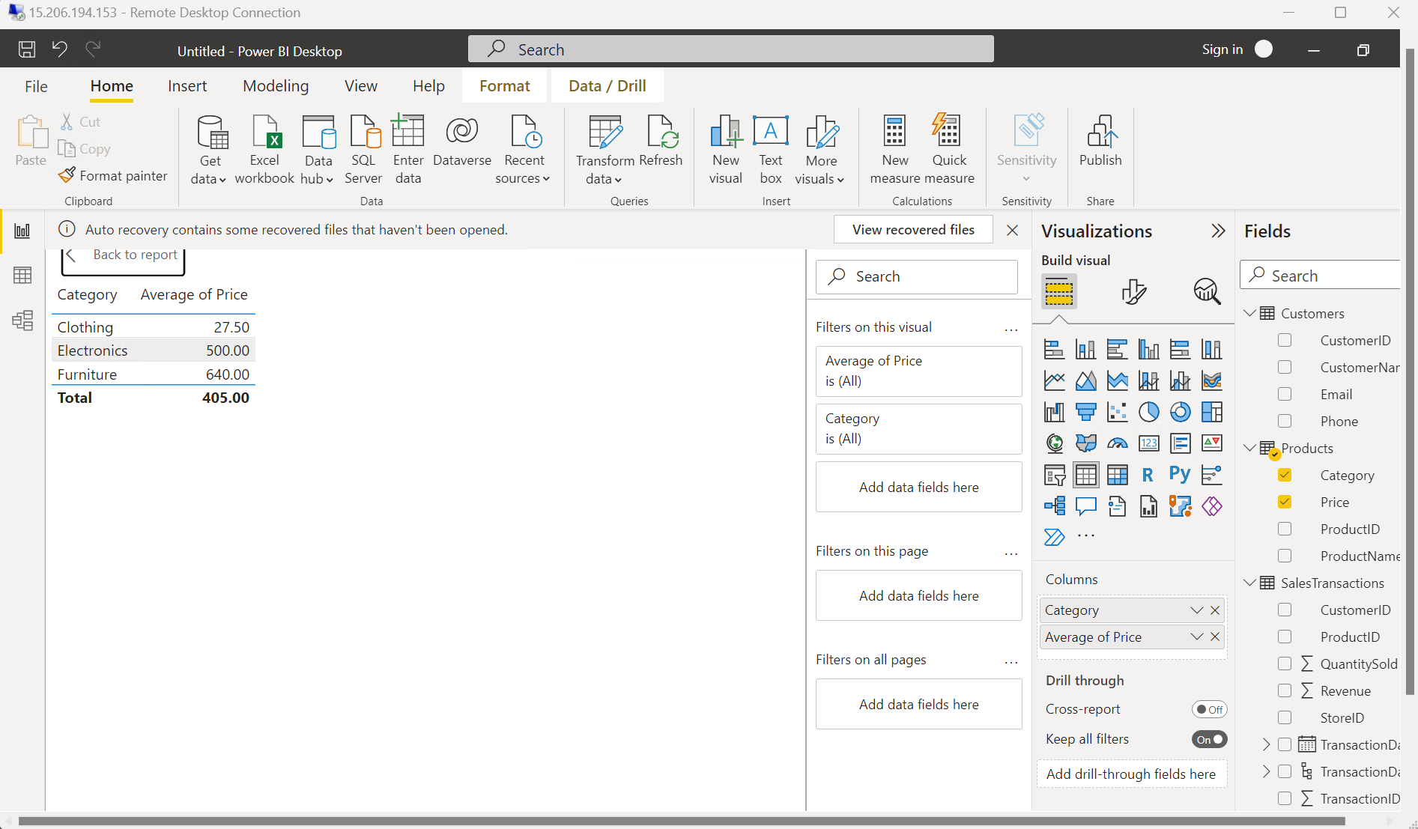

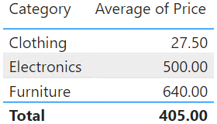

1. Are there specific days of the week when sales are higher?
2. Average price of product in each category
3. 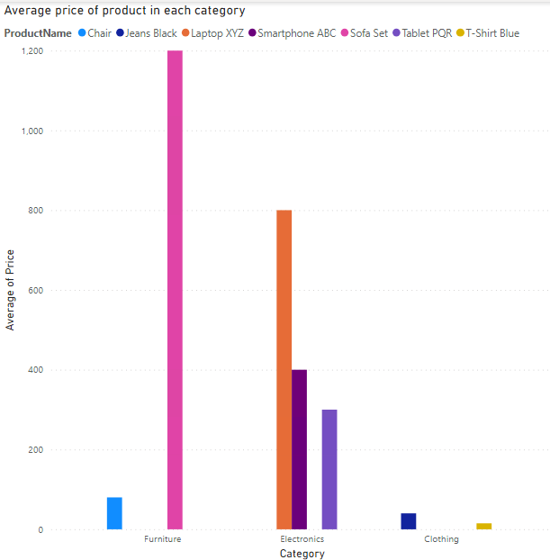
4. 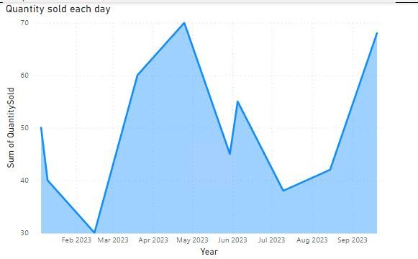
5. 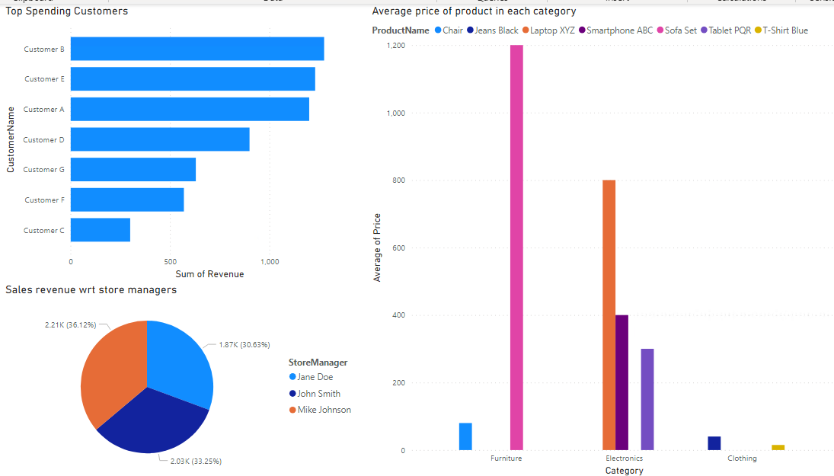
6. 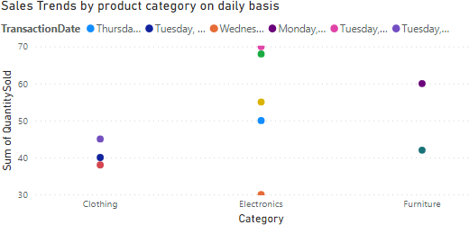
7. 